**WEB PROGRAMING PRACTICUM REPORT**

**MODULE 3**

**PHP**



**CREATED BY :**

**KURNIAWAN BAGASKARA**

**L200214253**

**INFORMATICS STUDY PROGRAM**

**FACULTY OF COMMUNICATION AND INFORMATION SCIENCE**

**MUHAMMADIYAH SURAKARTA UNIVERSITY**

**1. Write a PHP script to create a sum program**

**use variable function like below.**

**Then print the resulting screen in the browser, and attach it**

**in reports.**

<!DOCTYPE *html*>

<html>

<head>

    <title>Program Penjumlahan</title>

</head>

<body>

    <form *method*="POST" *action*="penjumlahan.php">

        <p>Nilai A adalah <input *type*="text" *name*="nilaiA" *size*="1"></p>

        <p>Nilai B adalah <input *type*="text" *name*="nilaiB" *size*="1"></p>

        <p><input *type*="submit" *name*="submit" *value*="Jumlahkan"></p>

    </form>

<?php

error_reporting(E_ALL ^ E_NOTICE);

$nilaiA = $_POST["nilaiA"];

$nilaiB = $_POST["nilaiB"];

$submit = $_POST["submit"];

if ($submit) {

    echo "Nilai A adalah $nilaiA <br>";

    echo "Nilai B adalah $nilaiB <br>";

    echo "Jadi nilai A ditambah nilai B adalah " .($nilaiA + $nilaiB);

}

?>

</body>

</html>

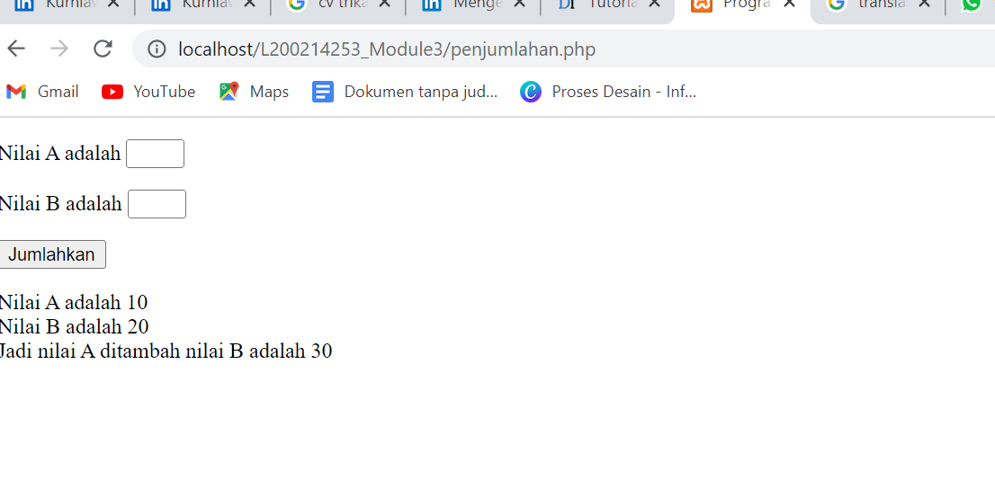

1. **Write a program to determine what a number is**

**odd or even by using PHP script.**

<!DOCTYPE *html*>

<html>

<head>

    <title>Program Ganjil & Genap</title>

</head>

<body>

    <h1>Program Menentukan Angka Ganjil dan Genap</h1>

    <form *method*="POST" *action*="ganjilgenap.php">

        <p>Bilangan anda : <input *type*="text" *name*="bilangan"></p>

        <p><input *type*="submit" *name*="submit" *value*="Cek"></p>

    </form>

<?php

error_reporting(E_ALL ^ E_NOTICE);

$bilangan = $_POST["bilangan"];

$submit = $_POST["submit"];

if ($submit) {

    if ($bilangan % 2 == 0) {

    echo "Bilangan $bilangan adalah bilangan genap";

    }

    else{

    echo "Bilangan $bilangan adalah bilangan ganjil";

    }

}

?>

</body>

</html>

